**PROBLEM STATEMENT:**

Getting a loan is very tiring and complicated process in India. It may take weeks or months for loan to get approved and people have to visit the loan office again and again. “LBI” portal is a web application that can be used for applying for loan online without visiting any bank branch. Applying for loan online helps people get around despite the fact that they have to visit branch for any bank related work. The individual who needs loan can just visit our online portal. This system increases customer retention and simplify loan and EMI management. This project is designed to be used by any individual for home loan, Vehicle loan or Education loan. It is an online system through which customer can view available services its benefits and other information related to loan. The system will be based that takes the individual information and then verify if user meets the eligibility criteria. If user is satisfying all the requirements, then loan gets approved.

Money is considered as the life line of an economy. It not only helps consumers in facilitating their transactions of goods and services but it also helps producers in meeting with their requirement of hiring the factors of productions to produce goods and services in the economy. Our service is the only organization which help both the consumers as well as producers in facilitating their activities. They provide the debit and credit facilities to their customers (consumers and producers). For sound and efficient functioning of the economy it is important that these services of debit and credit must be provided to customers at the lowest possible cost in the most integrated manner to maintain pace with the ever changing economic system.

HOME PAGE:

* Home page contains all the information about company services, schemes, policies, all the important links, about the company.
* Even home page contains EMI calculator, so that customers can loan according to their requirement

Contact us

About us(static)

affiliates

logo

register

login

EMI Calculator

schemes

Loan services

home

Company related image

Main highlights like offers and all(static)

* Home page contains all the information about company services, schemes, policies, all the important links, about the company.

home

Information about company in image format

Module1: HOME LOAN

* When we click on loan services we will get types of loan the company offering to the customers.

service

Home loan

home loan

Apply for loan

regsiter

login

Application form for home loan

Model to send response to customer with status regarding loan application

Confirmation pop up for the user..telling wait for the approval

Apply link for home loan

* when you click on register page, once the registration completes it directly re-directs to the loan application form

REGISTER HERE

NAME:

EMAIL:

CITY:

MOBILE NUMBER:

PASSWORD:

CONFIRM PASSWORD:

REGISTER

* if the customer is already registered, customer has to login using login page.

Login here

email:

password:

Forgot password

login

Application form for home loan

Personal details

name of the borrower:

gender:

date of birth:

email:

adhar number:

constitution of the borrower:

nationality:

category:

permanent address:

pincode:

telephone number:

PAN number:

Voter id number:

next

Applicant employement details

Your applying as a:

If salaried, nature of organization:

Occupation:

Designation:

Name of the organization:

Address of the organization:

And all information fields:

Submit

Module 2: VEHICLE LOAN

* when we click on loan services we will get types of loan the company offering to the customers.
* When we click on vehicle loan

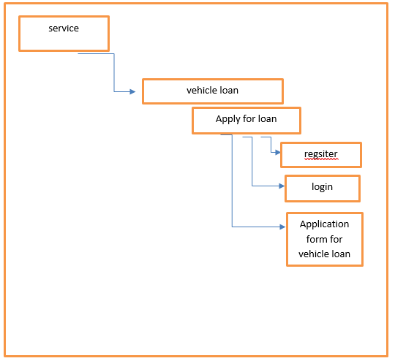

* when you click on register page, once the registration completes it directly re-directs to the loan application form

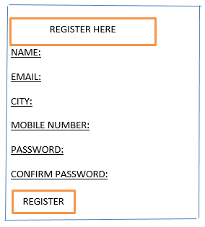

* if the customer is already registered, customer has to login using login page.

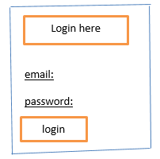

Application form for vehicle loan

Personal details

name of the borrower:

gender:

date of birth:

email:

adhar number:

constitution of the borrower:

nationality:

category:

permanent address:

pincode:

telephone number:

PAN number:

Voter id number:

next

Applicant vehicle details

Occupation:

Designation:

Name of the organization:

Address of the organization:

Type of vehicle:

Submit

FORGOT PASSWORD:

EMAIL ID:

SUBMIT